How to Change a Tire

Tess Baucom

Contents

Introduction 3

Why do I Need to know how to Change a Tire? 3

Equipment 3

List of Equipment 3

Getting a Flat Tire 4

How to Change a Tire 5

Removing the Flat Tire 5

Placing the Spare Tire 6

What to Do with the Flat Tire 7

Glossary 8

# Introduction

Many people today are familiar with changing a tire through the media – we often find our unlucky heroes stuck on the side of the road in television and movies. In *A Christmas Story*, we watch Ralphie learn how to change the car’s tire on the side of the road and learn how important it is not to lose the lug nuts. Although this problem may seem dated, flat or blown tires are still a very present problem today. While modern technology and convenience have certainly improved how we solve such a problem, knowing how to change a tire yourself can save you time, money, and even keep you safe.

## Why do I Need to know how to Change a Tire?

With Google at your fingertips, or Triple-A a simple phone call away, you may think it a waste of time or unnecessary to learn how to change a tire yourself. Although a time before smartphones made this knowledge much more commonplace, you may find yourself without a phone (or cell signal) even in 2023. When that happens, knowing how to change a tire from memory becomes invaluable, as being stranded on the side of the road with a broken-down vehicle can be dangerous for a variety of reasons. Inclement weather, like tornados, hurricanes, or snowstorms can cause injury or even death. Alternatively, other drivers and motorists may not see you on the side of the road and may hit your or your vehicle. Even without such hazards present, without a phone or the funds necessary to move a broken-down car, you may be stuck there indefinitely. Knowing how to change the tire yourself and getting your vehicle moving again is convenient in the best of times and can even be lifesaving in more dire circumstances.

# Equipment

You may not even be aware that, unless the equipment was moved or misplaced previously, every car comes equipped with all necessary tools to change a tire – including the spare. In a smaller sedan, this equipment is found in the trunk, in a compartment built into the trunk’s floor. In larger SUVs, the equipment may be found underneath the floor mat in the trunk or in the circular encasement on the back of the rear door.

Caution: The intended purpose of a spare tire is to allow the vehicle to travel far enough to get the flat tire repaired or replaced; it is not meant to fully replace a blown tire. When using a spare tire, travel should be kept to a minimum.

The spare tire will most likely be smaller and harder than your normal car tires. You may have heard someone reference a “Donut” when talking about cars or tires; this small, spare tire is the Donut.

## List of Equipment

* Spare tire
* Lug wrench
* Scissor jack
* Crowbar
* Lug nut key*

The first three items listed – the spare tire, wrench, and jack – are generally all that are needed to change a tire. However, in some cars, one of the 5 lug nuts is different; this is a locking nut, which helps prevent tire theft as it requires a special key to be removed. If your car is equipped with locking nuts, the lug nut key will be included with the wrench. The key simply attaches to the wrench, allowing the lock nut to be removed the same as the others. If your car does not have locking nuts, you will not have a lug nut key, nor will you need one to proceed. The lug wrench suffices for all 5 nuts.

Below is an example of a locking nut; they are easily identified by an indentation or shape particular to that specific nut.

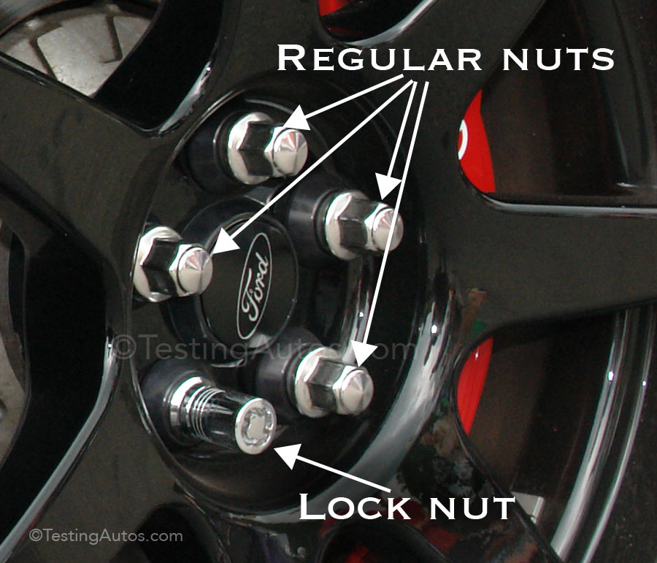

Figure 1 Lock Nut

# Getting a Flat Tire

If you notice a flat tire while your vehicle is already parked (in your driveway, in a parking lot, etc.) it is best to not move the car and change the tire there. If you are actively driving when a tire goes flat, the TPMS (Tire Pressure Monitoring System) indicator light turns on, and you may notice a loud, rhythmic, thumping sound as you drive. When a tire blows, there will be a loud explosion and the car jolts.

Warning! It is important to not drive on a flat tire because driving on the rim can cause damage that is very expensive to fix. Driving a small distance to find a safe place to pull over is okay, but immediate action should be taken to ensure that excessive damage does not occur to the vehicle.

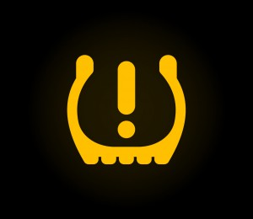

Figure 2 TPMS Light Indicator

# How to Change a Tire

Once you are stopped in a safe area you can begin to change your tire. Remove the spare, lug wrench, and jack from the trunk and place it near your flat tire.

## Removing the Flat Tire

1. Place the scissor jack under the car’s frame. The shape and placement of the frame varies by make and model, but the following diagram in **Figure 3** shows general placements for jack lifts. The most accessible placements are usually on the side of the car, between the front and rear wheels. Place the scissor jack close to the wheel you are working on.

Danger! It is important that the jack is placed under a secure part of the car’s frame. If misplaced, the jack may slip or the weaker parts of the cars structure may give out, causing the car to collapse down. This can cause severe injury.

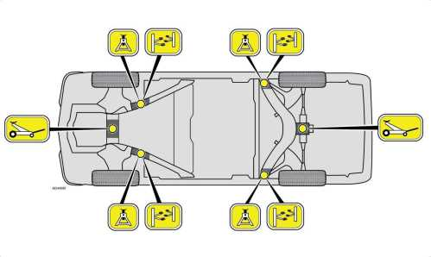

Figure 3 Frame placements

1. Insert the crowbar into the end of the scissor jack and twist. Lift the jack until the tire is fully removed from the ground.

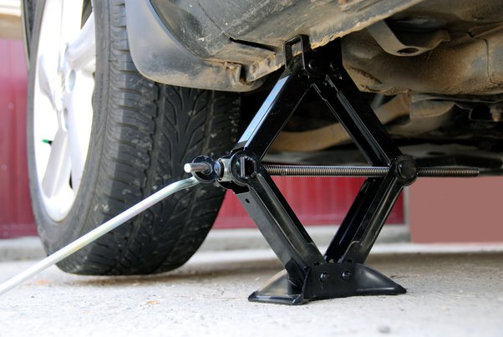

Figure 4 Lifted scissor jack

1. Use the wrench to remove the 5 lug nuts by turning them counterclockwise.
2. If there is a lock nut, insert the lug nut key into the wrench and remove the lock nut.
3. Place the lug nuts in a secure location. There may be a pouch provided to hold the wrench and lug nut key (if provided) that can be used to store the nuts. If not, you can use a hat, purse, or even place the lug nuts in a cupholder or on one of the seats. Do not place the nuts on the ground, as they can roll away or be misplaced.
4. Pull the flat tire away from the car to remove it off the rim. If this does not happen right away, you can kick the tire (repeatedly, if necessary) or wiggle each side to loosen it. Set the old tire to the side.

Danger! Do not climb underneath the car to try to remove the tire. Although the scissor jack should firmly stay in place, the force used to loosen a stuck tire may cause the jack to slip or fail. The car may fall, causing serious injury or death.

## Placing the Spare Tire

1. Place the spare tire securely over the rim.
2. Place one lug nut in place and using your hand, start screwing it in place clockwise. Do not fully tighten the lug nut.
3. Use the following diagram (Figure 5) to place the second bolt, following a star pattern. Do not fully tighten the nut.

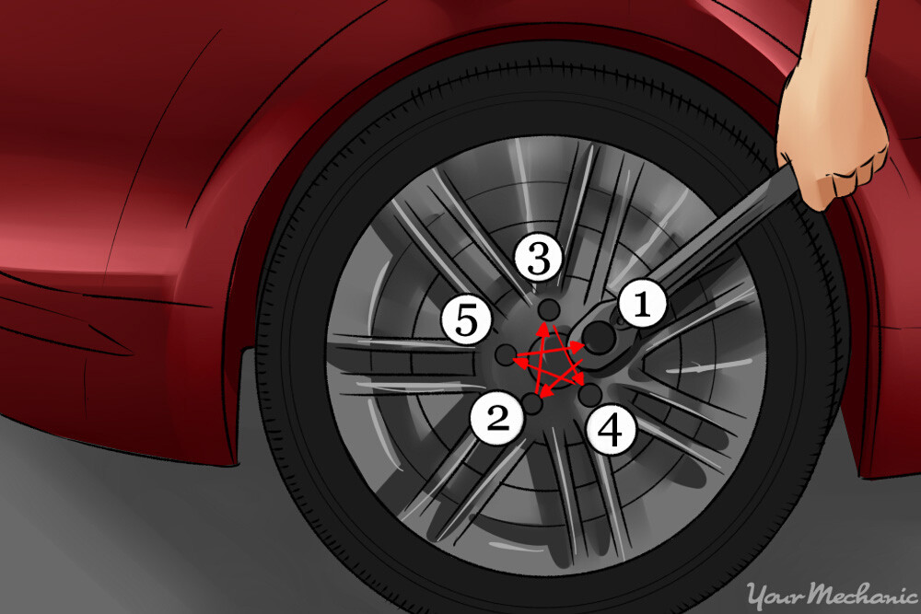.

Figure 5 Lug nut pattern

1. Place the final 3 nuts following the star pattern. Both regular and lock nuts can be placed by hand in this step.

Caution: The nuts are secured in a star pattern to help ensure that the pressure is distributed evenly over the tire. Unequal pressure can cause excessive wear or damage to the tire or vehicle.

1. Once all five nuts are loosely in place, use the wrench to fully secure the first bolt you started with. Tighten each bolt in the order in which you placed them, following the same star pattern.
2. If you have a lock nut, use the lug nut key to fully tighten the lock nut.
3. Ensure that the spare tire is fully secured. Use the crowbar to lower the scissor jack. Place the equipment and the flat tire back in the trunk.

# What to Do with the Flat Tire

Now that you have a spare tire in place, you can safely travel to a hardware store or mechanic. A spare tire is safe to use for a few days, if necessary, however it cannot act as a permanent replacement for the tire. Although helpful in an emergency, the size discrepancy can cause uneven wear on the vehicle and affect gas mileage.

If your tire is simply flat, it can be repaired with a tire patch kit. You can purchase the kit yourself at a hardware store or take the tire to a mechanic. If the tire blew, or has a tear in the sidewall, it cannot be repaired and needs to be replaced with a new tire.

# Glossary

|  |  |
| --- | --- |
| Term | Description |
| Donut | A common term for spare tire |
| Locking nut | A nut with a special design or indentation to prevent theft |
| Lug nut | The bolts used to keep tires attached to the wheel of the car |
| Lug nut key | A wrench attachment used to loosen and remove the locking nut |
| Lug wrench | The wrench provided to loosen and remove lug nuts |
| Scissor jack | The jack provided to lift the car, small and scissor-like in appearance |
| Spare (tire) | The small, hard tire that replaces the flat or blown tire |